Next Meet will be on September 7, 2003 at
Buchser Middle School, 1111 Bellomy St., Santa Clara, CA

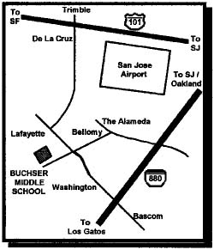
Doors Open Promptly at 9:00 AM with Auction Bid Cards distributed by 9:30 AM.

Clinics at 10:00 and 11:00 AM

10 AM Ted Culotta – War Emergency Freight Cars
11 AM Dave Biondi – Basics of Background Painting

11 AM Dave Connery – Railroad Roundtable

Noon Business Meeting

3:30 PM or End of Auction, which ever comes first.
Raffle and Door Prize Drawing
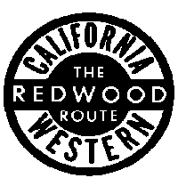
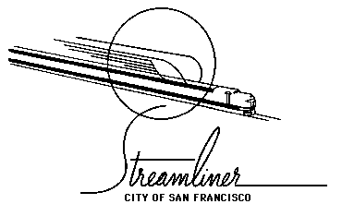

Coast Dispatcher
47464 Cholla St.
Fremont, CA 94539

