Auction Update by Bill Burket

You all know how the auction works. Rather then the auction reminder and update I need to pause and share some thoughts with all of you.
In this world there are a few exceptional people who come along once in a lifetime. Most of us are overloaded and running from one place to another for meetings, appointments, etc. and for the most part taking everything for granted. One thing I'm guilty of is always having something to complain about.
It is such a gift for me to have been so well acquainted with Todd Bendigkeit. Never once did I ever hear him complain about anything. When it came to the auction he was always there to help. He did it all except auctioneering.

He gave out cards, put items in numerical order, watched items on the tables, and assisted other members looking at auction items. For the last meet, which I couldn't attend, he helped my son Joe set up the auction. I called him ahead of time and without hesitation he said he would be there to help. I wonder how many of us are very able and don't have time for others.
Todd never let his disability get in the way of being there for others. When the going got tough he didn't sit there. He got going. He and Rick Weil were the "Peanut Gallery" in the front row. I know that St. Peter has given Todd that "Peanut Gallery" seat. His is an example of how to give to life the fullest. I will always remember this about him. So, God speed my friend.
Bill Burket, Coast Division Auction Chairman

Allan Fenton Switching Contest by Jim Long

Tom Van Horn again ran the Allan Fenton Switching Contest at the June Coast Meet. There were 4 first time contestant. Many enjoyed the activity. The results are:

As you can see the six car problem seems to have a lower time than the 5 car problem. This tells me that practice makes perfect or maybe just a lower time. Give the switching contest a try. Then try again until you improve your time. Switching is fun.

Brake Person 5 Car Problem
First Place Robert Ray 9:34
Second Place Bob Jacobsen 14:34 First Attempt
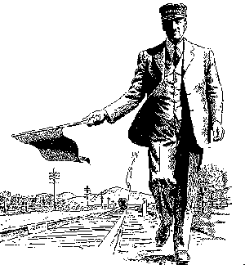
Third Place Howard McClintock not recorded

Senior Brake Person 6 Car Problem
First Place Alan Havens 5:46
Second Place Tom Crawford 6:48
Third Place Jim Wanlass 12:26

