Next Meet will be on September 8, 2002 at
Buchser Middle School, 1111 Bellomy St., Santa Clara, CA
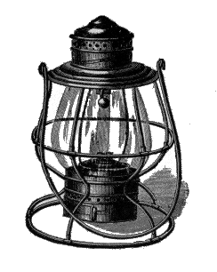
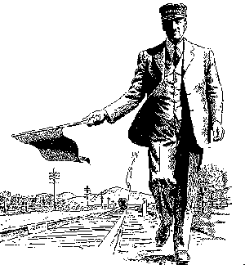
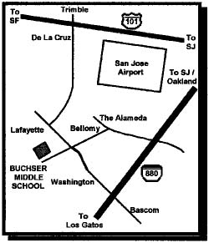
Doors Open Promptly at 9:00 AM with Auction Bid Cards distributed by 9:30 AM.

Clinics at 10:00 and 11:00 AM

10 AM “Some of my Railroad Collectibles and Their Story”
with Bill Burket
10 AM “DCC Made Easy (with modular HO layout) 1.5 hrs”
with Don Fiehmann

11 AM “Model Railroading Roundtable”
with Dave Connery as moderator

Noon Business Meeting

3:30 PM or End of Auction, which ever comes first.
Raffle and Door Prize Drawing

Coast Dispatcher
47464 Cholla St.
Fremont, CA 94539

