Next Meet will be on September 9, 2001 at
Buchser Middle School, 1111 Bellomy St., Santa Clara, CA


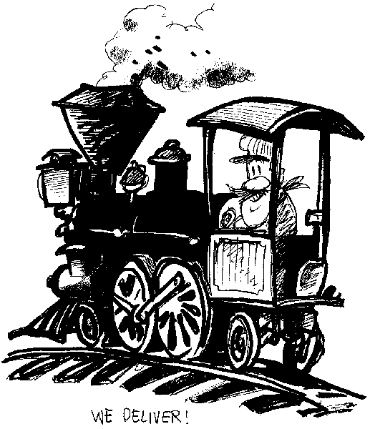
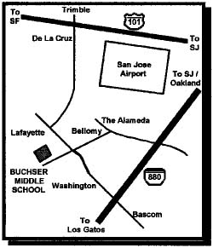
Doors Open Promptly at 9:00 AM with Auction Bid Cards distributed by 9:30 AM.

Clinics at 10:00 and 11:00 AM
10 AM "What an Auction Volunteer does and why you
should volunteer" By Bill Burket and Others
10 AM "Machining for Modelers - Part 2"
By Steve Smith
11 AM "Model Railroading Roundtable"
with Dave Connery as moderator
11 AM "Soldering 101 - Back to Basics"
By John Marshall

Brief Board Meeting at 12:00 Noon, followed by Auction

Coast Dispatcher
47464 Cholla St.
Fremont, CA 94539

