Modeler’s Roundtable by Dave Connery

At the June meet at Fremont we held our first Modelers roundtable and while the group was small, we did get into some interesting areas. Like most of the meet, we spent some time discussing the plight of the NMRA - not what this was designed for but interesting, none-the-less. We did get a chance to talk a bit about several modeling subjects such as altering Shinohara turnouts to make them more DCC friendly, modeling a copper mill and everyone shared what we are currently interested in modeling. We will do it again in September in Santa Clara. The time is shown elsewhere in this issue of the Coast Dispatcher. Hope to see you there.

Dave Connery, Moderator

NMRA Pike Registry by Jim Long

One of the NMRA’s volunteer services programs is the Pike Registry Program. This is a place to register the name of your model railroad. You can also register the reporting marks. This program had become inactive some time ago but has now been taken over by a new volunteer. It is back and running again. When your register your railroad you get a certificate suitable for framing with your railroad name on it. The registry list your railroad, scale, reporting marks, visiting codes and exchange information. Your railroad name is not guaranteed that it is exclusive but it does certify that a registered pike has not been registered to another modeler. The cost is $5 for each name requested. Further information is available from.
Andy Hauser
416 Price St.
Calumet City, IL 60409
708-868-8749
The program is explained on the NMRA web site at http://www.nmra.org/pikereg/ NMRA lists the all the registered names on the web. There are several pikes that are registered to Coast Division and PCR members. Take a look at the web page and see how many you can find.

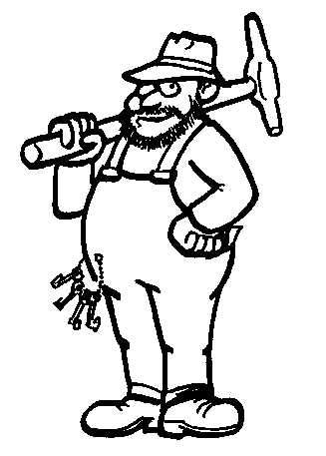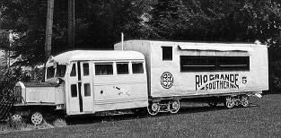

Rio Grande Southern’s Galloping Goose Number 5 was built on June 8, 1933 by Pierce Arrow using a 1928 bus body. The bus body was later rebuilt by Wayne Bus Company and the engine by GMC.

