Next Meet will be on March 3, 2002 at
Buchser Middle School, 1111 Bellomy St., Santa Clara, CA
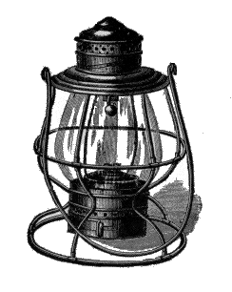
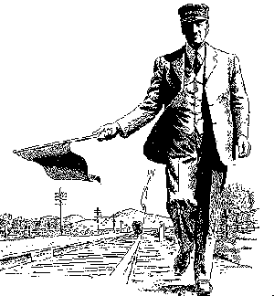
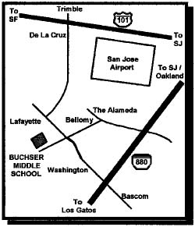
Doors Open Promptly at 9:00 AM with Auction Bid Cards distributed by 9:30 AM.

Clinics at 10:00 and 11:00 AM

10 AM Heavy snows in the Sierra
with Bill Burket
11 AM "Model Railroading Roundtable"
with Dave Connery as moderator
11 AM Identify and Model Trees
with Steve Smith

Noon Business Meeting

3:30 PM or End of Auction, which ever comes first.
Raffle and Door Prize Drawing

Coast Dispatcher
47464 Cholla St.
Fremont, CA 94539

