Next Meet will be on December 8, 2002 at
California School for the Deaf, 39350 Gallaudet Dr, Fremont, CA

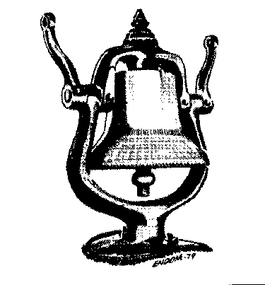

Doors Open Promptly at 9:00 AM with Auction Bid Cards distributed by 9:30 AM.

Clinics at 10:00 and 11:00 AM
10 AM “Scenery Basics ” By Dave Connery & Brad Lloyd
11 AM “Model Railroading Roundtable”
with Dave Connery as moderator
11 AM “The Time Capsule” Les Dahlstedt & John Marshall

Noon Business Meeting

3:30 PM or End of Auction, which ever comes first.
Raffle and Door Prize Drawing

Coast Dispatcher
47464 Cholla St.
Fremont, CA 94539

