Next Meet will be on December 2, 2001 at
California School for the Deaf, 39350 Gallaudet Dr, Fremont, CA

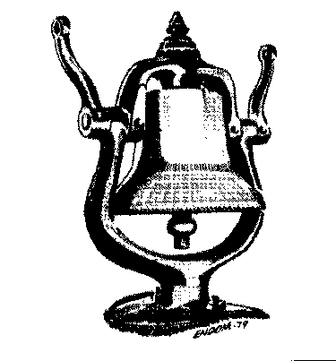

Doors Open Promptly at 9:00 AM with Auction Bid Cards distributed by 9:30 AM.

Clinics at 10:00 and 11:00 AM
10 AM “The Devil is in the Detail”
(Details Make The Difference)
By Dave Connery and Brad Lloyd
11 AM "Model Railroading Roundtable"
with Dave Connery as moderator
11 AM "Grandt Lines" By Dave Grandt

Coast Dispatcher
47464 Cholla St.
Fremont, CA 94539

